Wireless Security

Wireless Layer 2 Technology

Weight: 1.15% Marks:  /42

Student Name: Coleton Sanheim

Student ID: 000862545 Date: 2022-02-05

# Introduction

In this lab, you will focus on collecting and reviewing wireless traffic with various types of architectures.

Lab activities in this course will be marked in class. You must bring this document to every lab in the module. Each activity must be completed and then marked by the instructor before you move on to the next. To avoid a mark of zero for an activity, contact the instructor immediately if you cannot complete the activity for any reason, or if the activity was left unmarked by the instructor.

# Equipment

* Laptop with wireless capabilities
* Topology
* Wireshark with Npcap

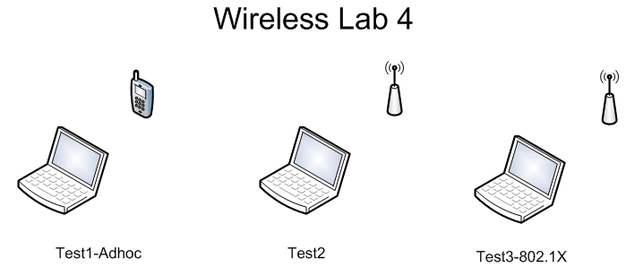

© 2017, Southern Alberta Institute of Technology

# Lab Setup

Before you begin the lab activities, perform the steps below to set up your computer.

1. Set up a Windows workstation with the following parameters:

* Wireless network adapter
* Latest version of Wireshark with Npcap

# Activity 4.1: Verifying Setup of the WiFi Radiator

1. Identify and set up the AP radiators (Test1-Adhoc, Test2, Test3-802.1X). (2 points)

**I used three different captures, all using the windows 10 machine, one with the adapter from sait secure wifi, one with adapter from home wifi and one without the adapter on home wifi.**

1. Verify that Wireshark can collect wireless traffic. (2 points)

**Attached pcap files in submission.**

1. Coordinate with your instructor during each radiator collection type. (2 points)

**Instructor sign-off:** __________________ (5 points)

# Activity 4.2: Collecting Data

1. Collect and save Test1-Adhoc. (2 points)
2. Collect and save Test2. (2 points)
3. Collect and save Test3-802.1X. (2 points)

**Attached will be the three pcap files I took for this lab.**

**Instructor sign-off:** __________________ (5 points)

# Activity 4.3: Performing Analysis

1. Analyze packet framing on wireless networks to understand the 802.11 header format and fields. Insert screen shots showing information for each type. (2 points)
   1. Test1-Adhoc
   2. Test2
   3. Test3-802.1X

**The 802.11 header format does not exist? I can not find a 802.11 header format in any captures packets.**

1. Analyze the 802.11 address field ordering and behaviour. Insert screen shots showing information for each type. (2 points)
   1. Test1-Adhoc
   2. Test2
   3. Test3-802.1X

**Again, as above, the 802.11 address field is not found anywhere in the pcap files.**

1. Analyze the operation and behaviour of IEEE 802.1X authentication, and insert a screen shot showing information for this type. (2 points)

**Again, no information relating to this has been captured.**

**Instructor sign-off:** __________________ (5 points)

# Activity 4.4: Summary Analysis

Write a short paragraph summarizing your analysis of the data you recorded. (2 points)

______**Unfortunately, the information this lab is asking for cannot be found, I am unsure if this is due to my set up being incorrect, or some other factor, but whatever the cause I looked through three different captures and could not find any of the information requested.______________________________________________________**

Does the information you obtained above support what you learned during the lecture? Explain. (2 points)

_________________________________________________________________________

_________________________________________________________________________

**Instructor sign-off:** __________________ (5 points)